# Computer Networks Lab Assignment 4

## Objective

* To configure static and default routing on routers to enable communication between different network segments.
* To use Cisco Packet Tracer to create a network with multiple routers and PCs and configure routing to ensure proper data transfer between devices.

## Steps taken to set up the network

**STEP 1:**  
 Set up the network by dragging required end devices (PC0 and PC1), and network devices (Router PT, 2 Switch 2960-24TT's) and connect them using straight through copper cables.

**STEP 2:**

Using the config table given, just label the devices with a text box with ip address and subnet mask to ease it up

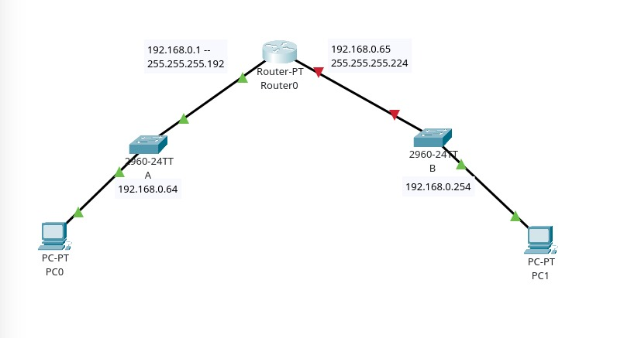

**STEP 3:**

Tap on Router-PT and navigate to the physical tab, add PT-ROUTER-NM-1CGE Module to the router after turning the power off, and turn on the power after adding at least two of those modules.

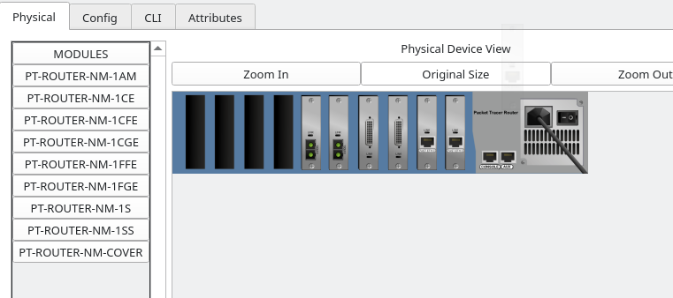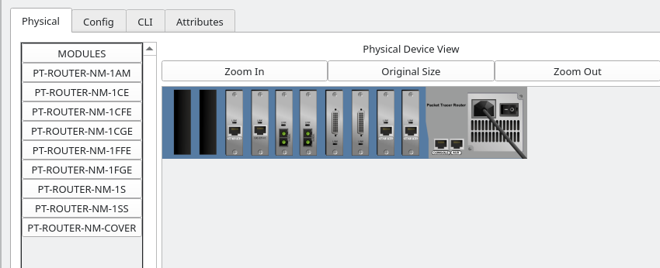**STEP 4:**

Now connect the Switches via Straight through the cable to the router PT on GigabitEthernet 6/0 and 7/0 respectively.

**STEP 5:**

Open the Router PT and open the CLI tab;

On CLI tab follow up with these commands below;  
 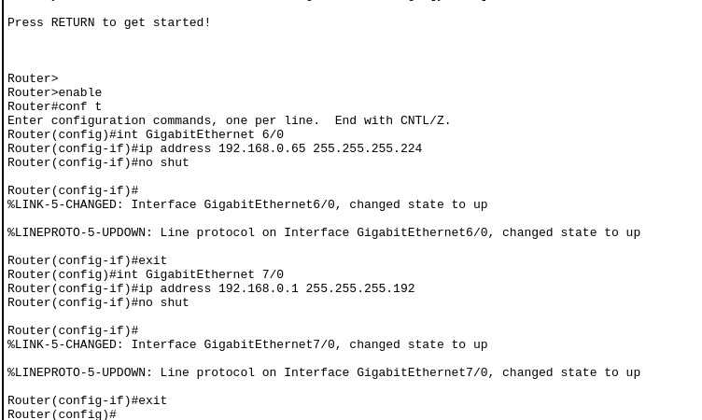

**STEP 6:**

Open switches and open the CLI and use the commands as shown

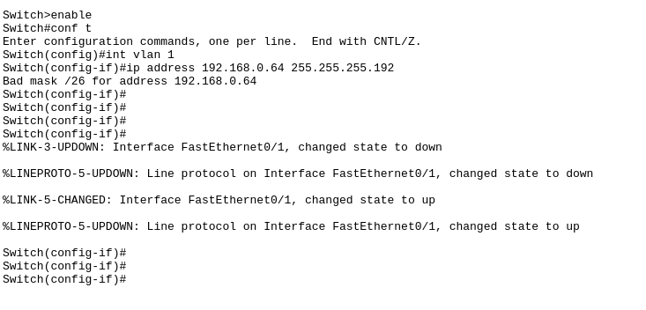

**STEP 7:**

Open the PC0 and PC1 and configure IP addresses  
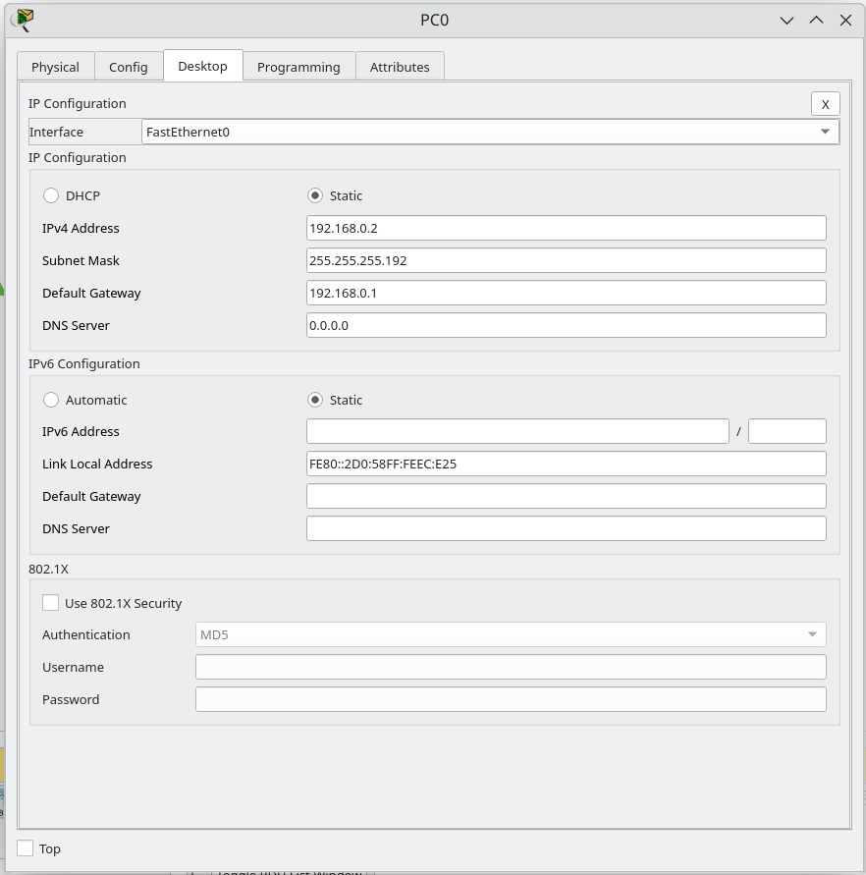

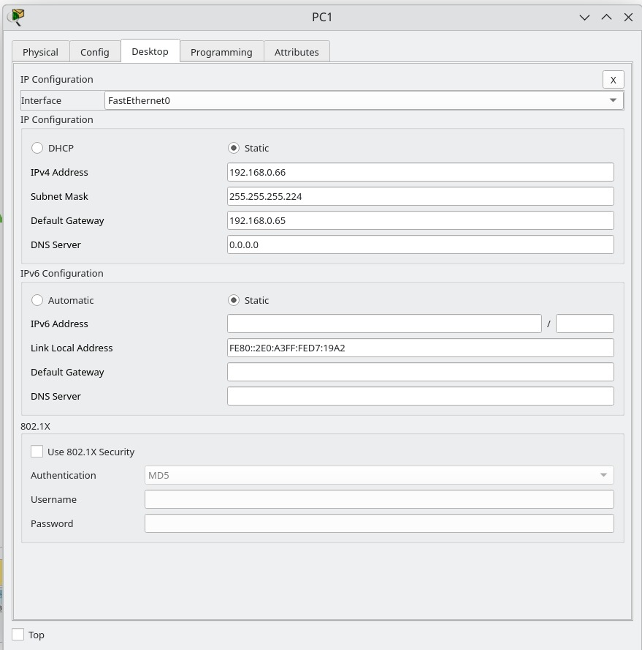

**STEP 8:**

Ping PC1 from PC0

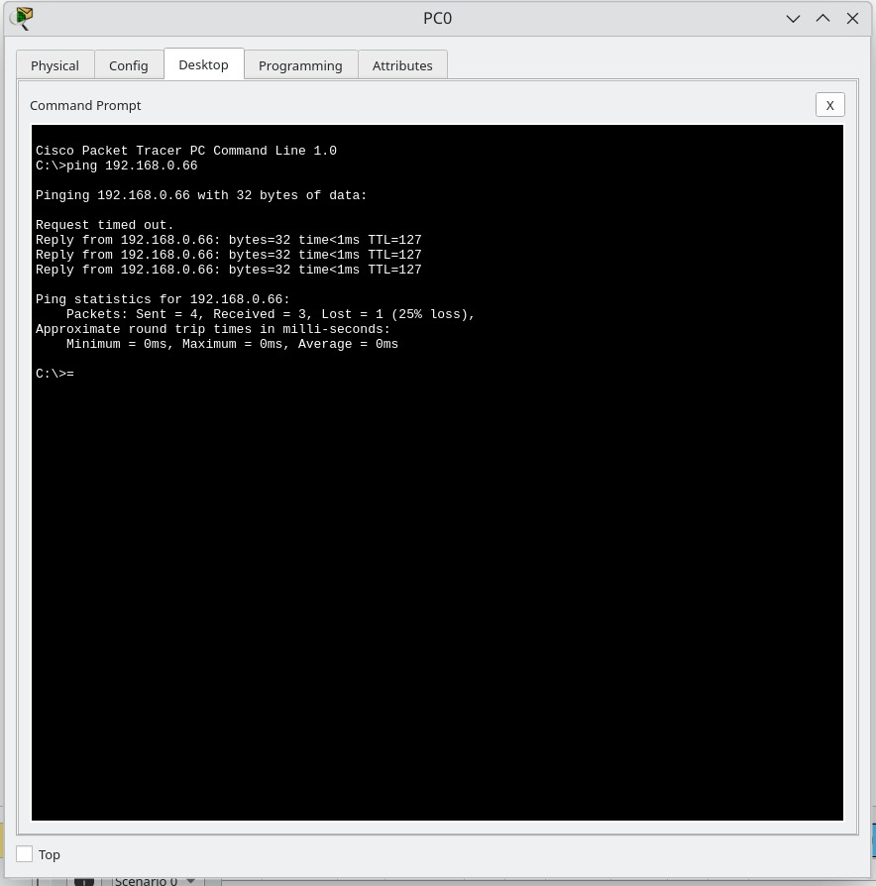

Simulation ping PC1 from PC0:

ARP REQUEST:

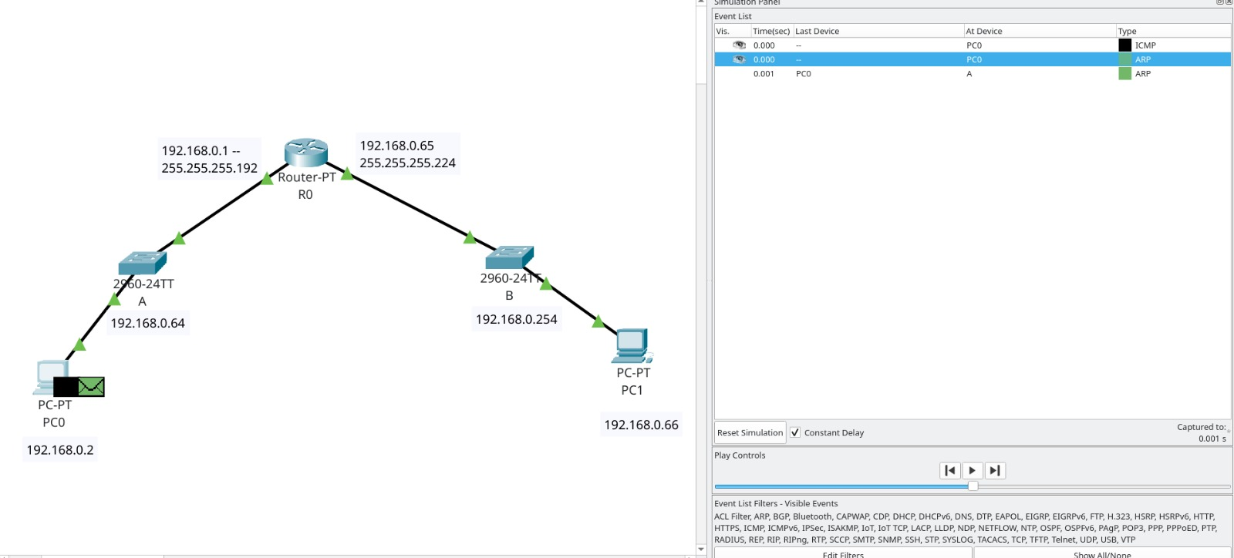

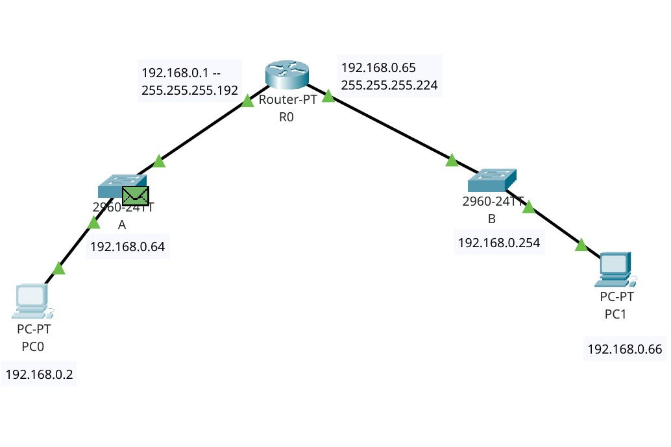 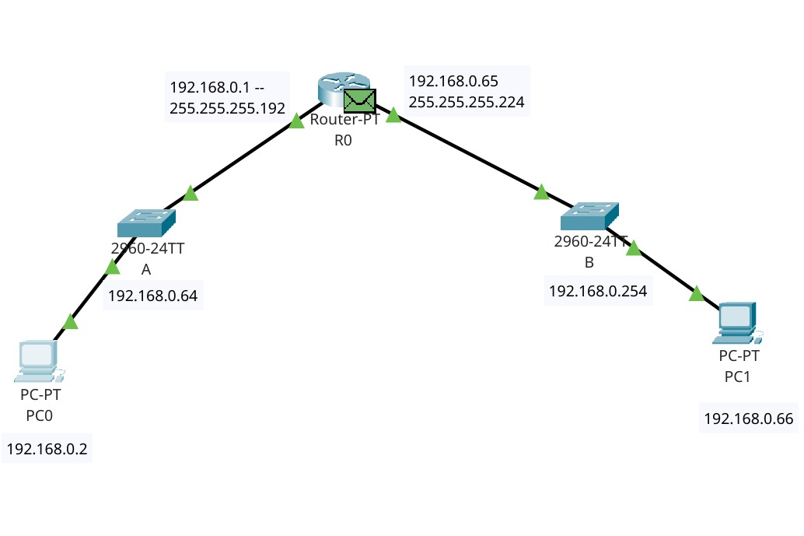ARP REPLY: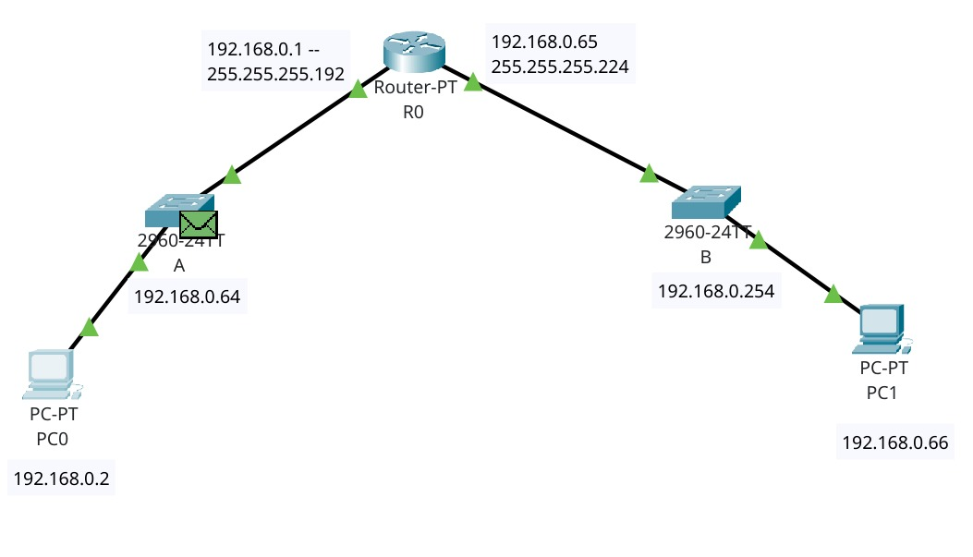

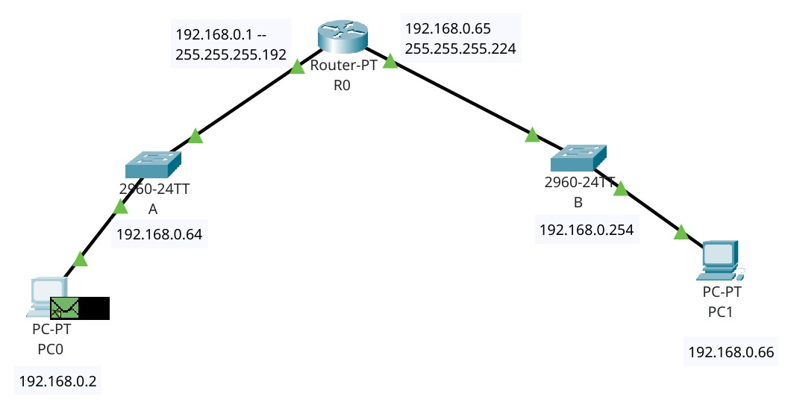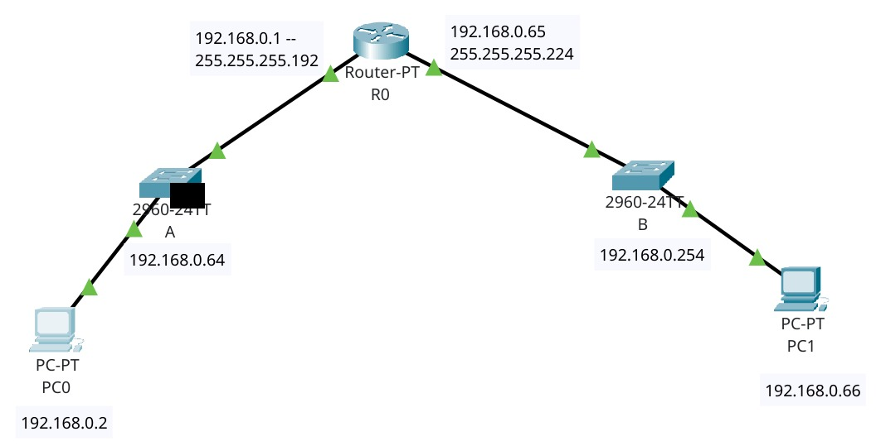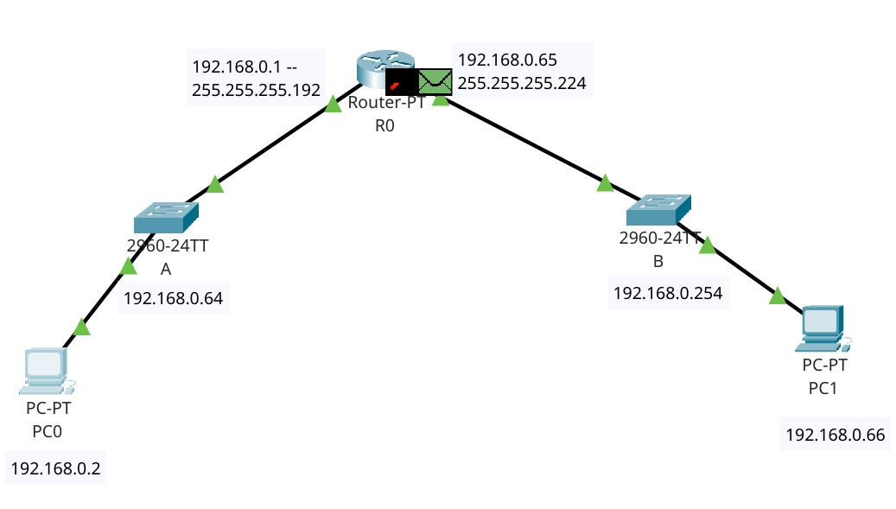ARP REQUEST:

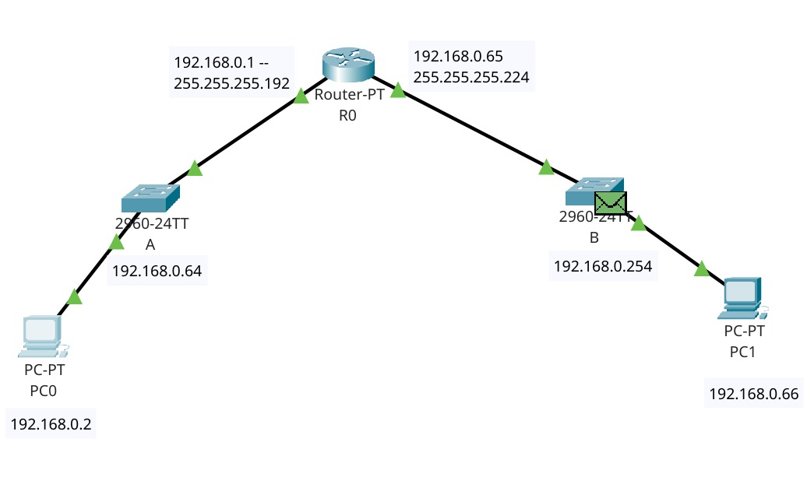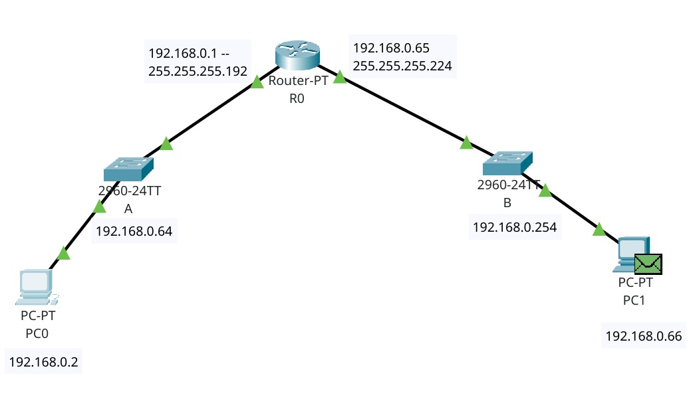ARP REPLY:

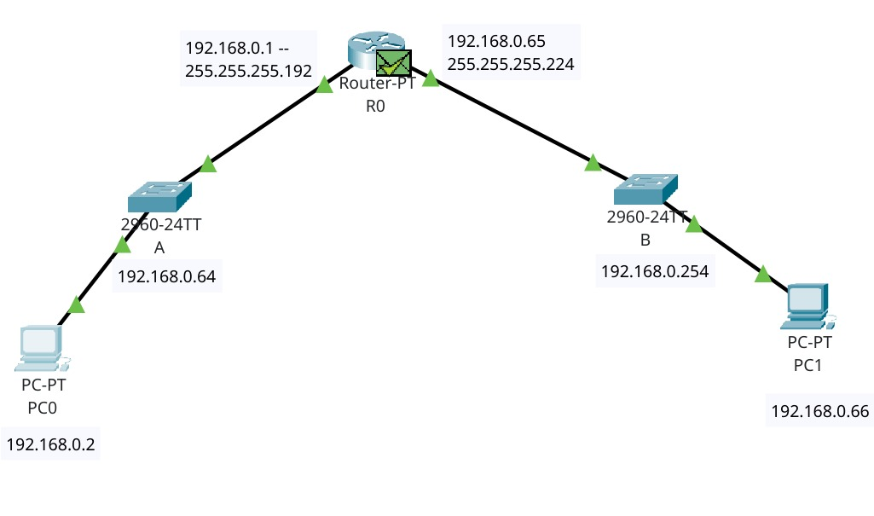

ICMP ECHO REQUEST:

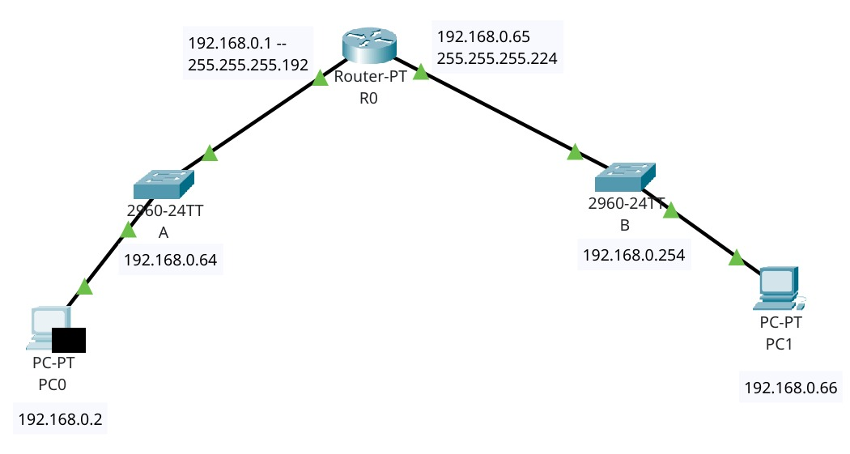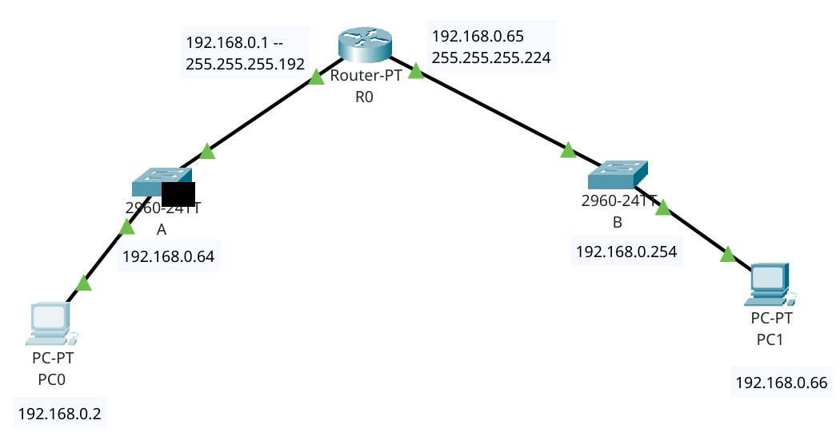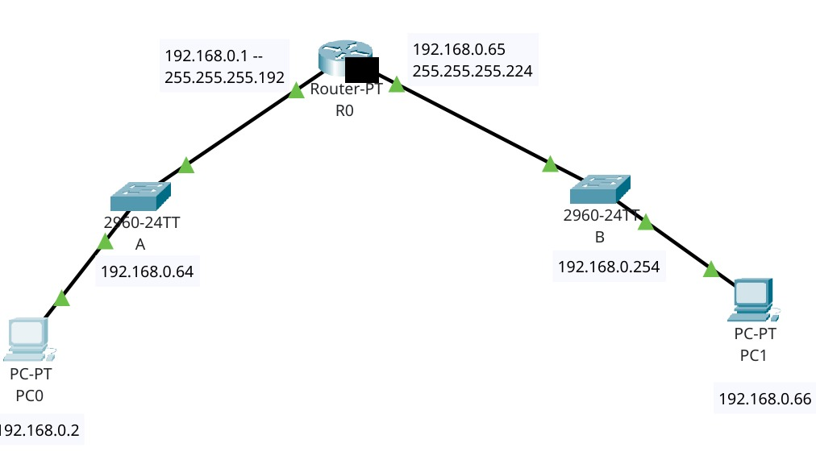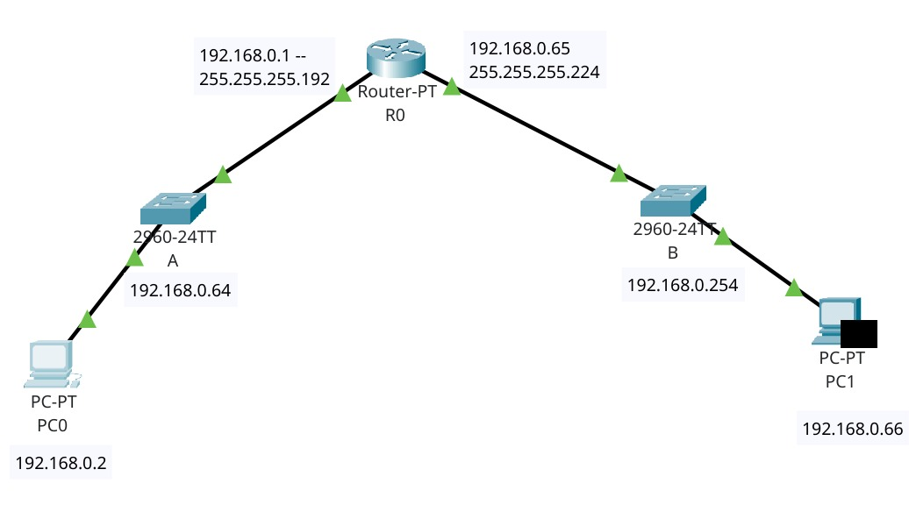

ICMP ECHO REPLY: